Name: Vishnu Vijayakumar
Roll No: 53
Batch: RMCA-B
Date: 23/05/2022

NETWORKING & SYSTEM ADMINISTRATION LAB

Experiment No.: 24

Aim
Install Docker and run on Ubuntu

Procedure
- Open the terminal on Ubuntu.

- Remove any Docker files that are running in the system, using the following command:
$ sudo apt-get remove docker docker-engine docker.io

Output Screenshot
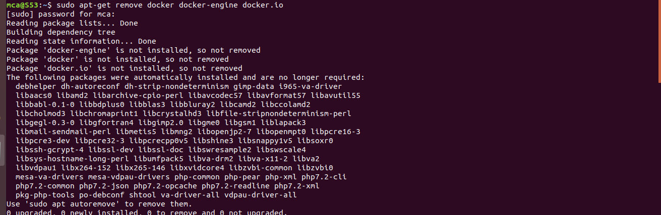

- Check if the system is up-to-date using the following command:
$ sudo apt-get update
Output Screenshot
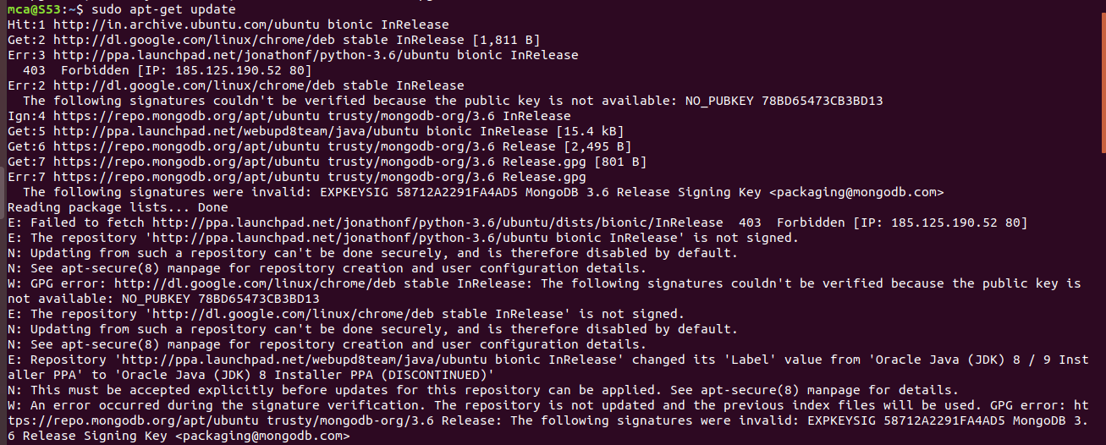
- Install Docker using the following command:
$ sudo apt install docker.io
Output Screenshot
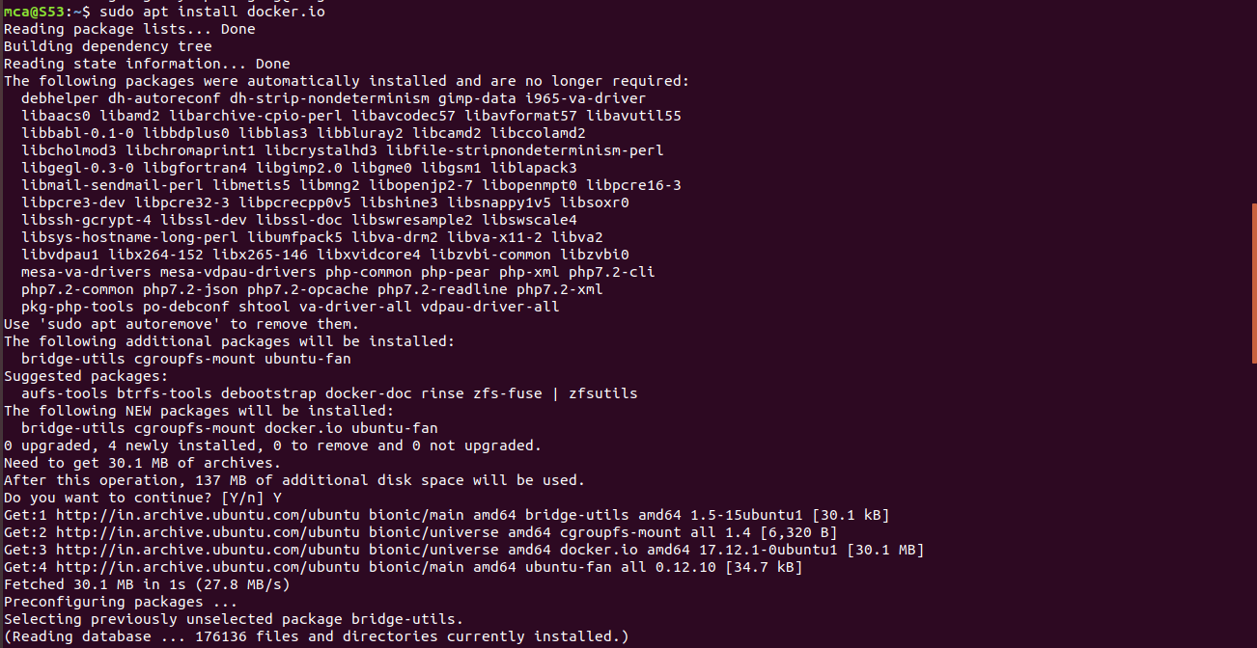

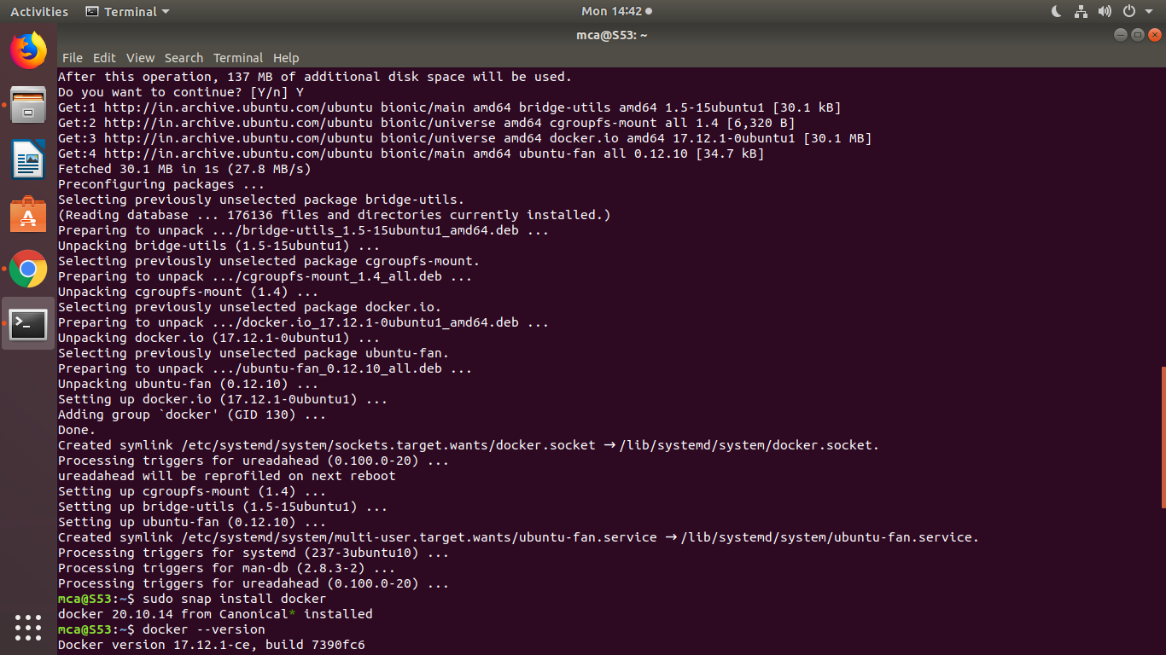
- Install all the dependency packages using the following command:
$ sudo snap install docker
Output Screenshot

- Before testing Docker, check the version installed using the following command:
$ docker --version
Output Screenshot

- Pull an image from the Docker hub using the following command:
$ sudo docker run hello-world
Output Screenshot
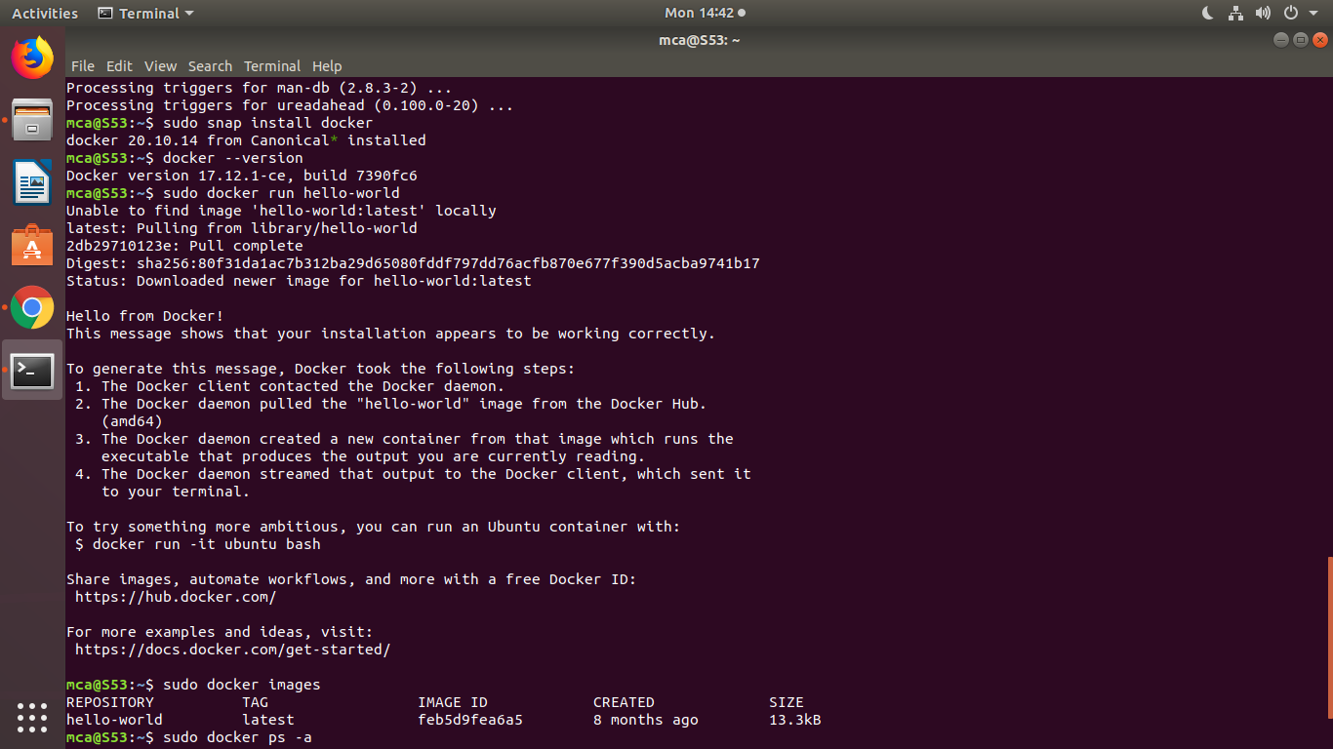

- Check if the docker image has been pulled and is present in your system using the following command:
$ sudo docker images
Output Screenshot

- To display all the containers pulled, use the following command:
$ sudo docker ps -a
Output Screenshot

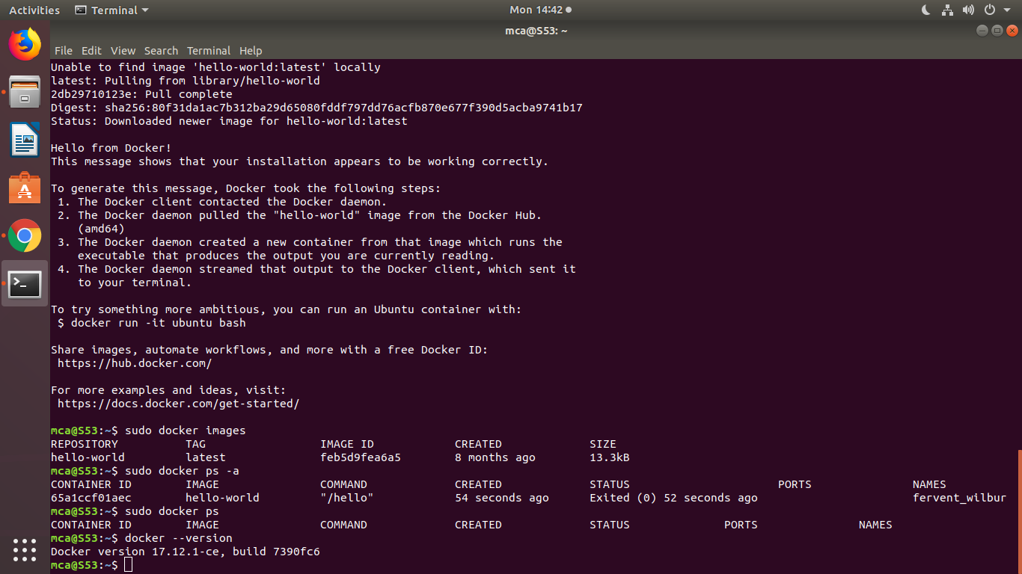

- To check for containers in a running state, use the following command:
$ sudo docker ps
Output Screenshot
You’ve just successfully installed Docker on Ubuntu!

